XMS interactive bulletin user menu

To provide an intuitive and highly functional interactive directory for the General Office, which include the following modules:

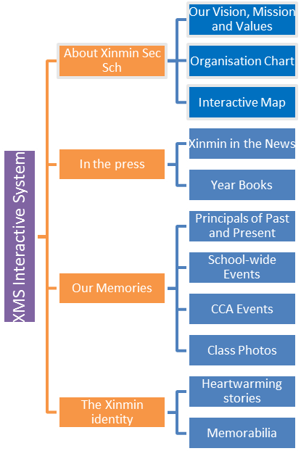

Screen Saver
- When the touch screen panel is inactive, the system will go into screen saver mode that shows events, news and videos
- School admin will be able to update the playlist through a simple update mechanism
- School admin is able to set the timeout period, time to display each image during screensaver mode

Quick Menu
Possible situated at one corner of the main page for users to directly link to:
- Interactive Map
- Organisation Chart

About Xinmin Secondary School
- Principal’s message – welcome to Xinmin Secondary School – text and image layout

Our Vision, Mission and Values
- This will most likely be laid out in a text and image layout where users read more about the school’s history, vision, mission, values, etc.

Organisation Chart
- The organisation chart lists the entire school personnel, and also according to department
- Users will be able to filter by department or search for a specific teacher by name
- School admin will be able to manage and update the module using the update process

Interactive Map
- A full map which lists all key areas of the school so that users can search by levels or categories
- Key locations will be ‘blinking’ for users to click on it
- Once a location is selected, the new page shows images and descriptions of the place

In the press
- A page with the most current news article of the school

Xinmin in the News
- A listing of all news pertaining to the school.
- Users will be able to browse through a list of news which will include images or videos.
- An update process is provided for school admin to manage

Year Books
- A listing of all the year books available as e-copies
- Users will be able to browse through each e-copy
- An update process is provided for school admin to manage

Our Memories
- A page that links to the other pages

Principals of Past and Present
- A listing of all the various principals over the years
- Users will be able to browse each principal, which will include text and image, possibly videos of interviews with the particular principal
- An update process is provided for school admin to manage

School-wide events
- A listing of all the various school-wide events over the years
- Users will be able to browse each event, which will include text and image, possibly short video clips
- An update process is provided for school admin to manage

CCA events
- A listing of all the various CCA events over the years
- Users will be able to browse each event, which will include text and image, possibly short video clips
- An update process is provided for school admin to manage

Class photos
- A listing of all the classes over the years
- Users will be able to browse each class photo, which will include text and image
- An update process is provided for school admin to manage

The Xinmin Identity
- A page that links to the other pages

Heartwarming stories
- A listing of illustrious alumni members
- Users will be able to browse each member’s story, which will include text and image, possibly videos of interviews
- An update process is provided for school admin to manage

Memorabilia
- A listing of various Xinmin memorabilia over the years
- Users will be able to browse each item, which will include text and image
- An update process is provided for school admin to manage

Interactive Learning Functions (Optional)
- Interactive applications for teaching and learning (especially of current affairs/news)
- For teachers to manage the content, which include creating and uploading of text/ images/ videos and simple MCQ or Fill in the Blanks questions
- Students to log in using their Student ID to do simple quizzes

